Lab 9-1 Exploring the Data Warehouse Application Console
Goals | To explore the revenue fact table, W_REVN_F, and its associated DAC entities.
Scenario | You have built the mappings and workflows to perform the ETL to load data into the WC_RVF_F fact table in the Siebel Relationship Management Warehouse. Now you must create tasks in DAC that can be used to run the workflows.
Outcome | You will have loaded data into the WC_RVF_FS staging table and the WC_RVF_F target table.
Time | 20 – 30 minutes
Environment | 
Instructions:
- Log into the DAC client.
  - Select Start > Programs > Siebel Analytics > Siebel DAC > DAC Client.
  - In the Login dialog box, enter the following and click Login:
Table owner name | SIEBEL
Password | SIEBEL
- Explore the table definition for W_REVN_F.
  - Click Design to open the Design view.
  - Click the Tables Top Pane tab.
  - Click Query in the Top Pane toolbar and query for W_REVN_F.
  - Click Go.
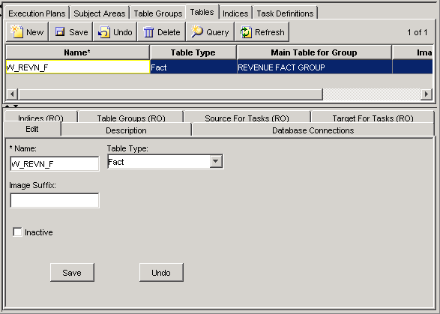
  - What is the table type of W_REVN_F?
  - Click the Database Connections child tab.
  - What is the database connection associated with the table? What can you infer from this?
  - Click the Target for Tasks child tab.
  - For which tasks is W_REVN_F the target? Which of these calls the Source Independent Load process that loads the bulk of the table?
  - Click the Table Groups (RO) child tab.
  - For which table group is W_REVN_F the main table?
- Explore the task that loads the W_REVN_F table.
  - Click the Task Definitions Top Pane tab.
  - Click Query in the Top Pane toolbar and query for Load into Revenue Fact.
  - Click Go.
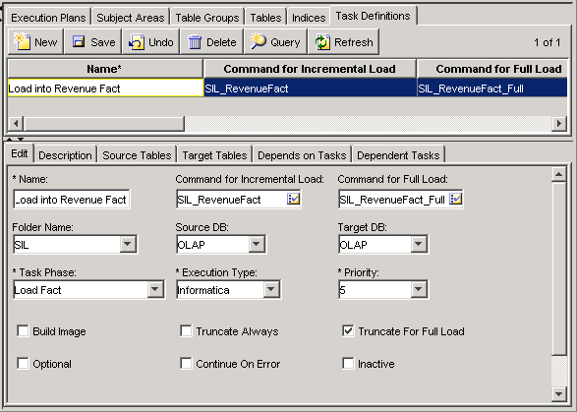
  - What is the execution type of the task?
  - What Informatica repository folder is the related Informatica mapping stored in?
  - What is the task phase of the task? What are some tasks that it might depend on?
  - Click the Source Tables child tab.
  - What is the primary source table for the task and what kind of table is it? What can you infer about the task that loads the primary source table for the Load into Revenue Fact task? How could you determine what task loads the fact staging table?
  - Click the Depends on Tasks child tab.
  - Which of the tasks listed loads the fact staging table sourced by the Load into Revenue Fact task?
- Explore the REVENUE FACT GROUP table group.
  - Click the Table Groups Top Pane tab.
  - Click Query in the Top Pane toolbar and query for REVENUE FACT GROUP.
  - Click Go.
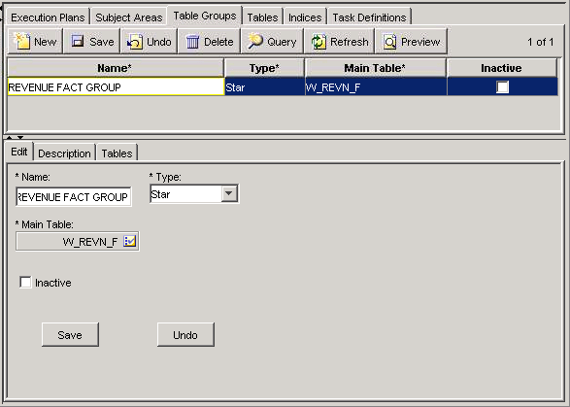
  - In the Edit child tab, confirm that the W_REVN_F table is the main table of the table group.
- Explore the subject areas to determine which include the REVENUE FACT GROUP.
  - Click the Subject Areas Top Pane tab.
  - Click the Table Groups child tab.
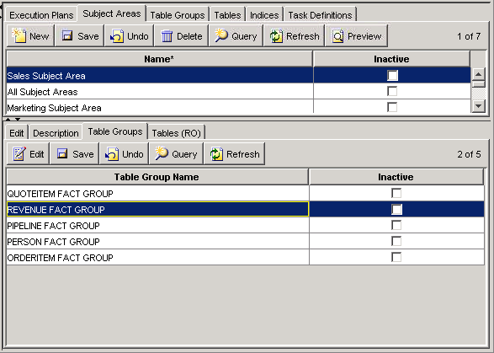
  - To explore the subject areas, select each in the top pane.
  - Which subject areas include the REVENUE FACT GROUP table group?
- Explore the execution plans to determine which will load the Revenue fact table.
  - Click the Execution Plans Top Pane tab.
  - Click the Subject Areas child tab.
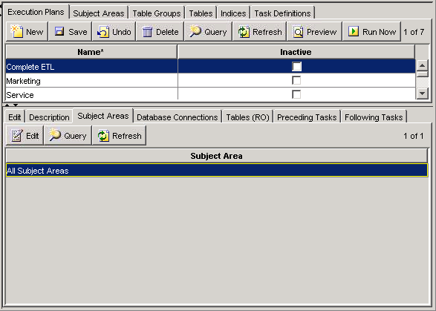
  - To explore the execution plans, select each in the Top Pane.
  - Which execution plans include All Subject Areas?
  - Which execution plans include Sales Subject Area?
  - Which execution plans would you run to load W_REVN_F and its related dimension tables?
Solutions 9-1 Exploring the Data Warehouse Application Console
Answers:
2.e. What is the table type of W_REVN_F?
Fact.
2.g. What is the database connection associated with the table? What can you infer from this?
The OLAP database connection is associated with W_REVN_F. This table is a warehouse table.
2.i. For which tasks is W_REVN_F the target? Which of these calls the Source Independent Load process that loads the bulk of the table?
W_REVN_F is the target for the Load into Revenue Fact, Update Days Open in Revenue Fact, and Update LineItemInd in Revenue Fact tasks. The Load into Revenue Fact task calls the SIL_RevenueFact process that loads the bulk of the table.
2.k. For which table group is W_REVN_F the main table?
W_REVN_F is the main table for the REVENUE FACT GROUP.
3.d. What is the execution type of the task?
Informatica
3.e. What Informatica repository folder is the related Informatica mapping stored in?
The SIL folder
3.f. What is the task phase of the task? What are some tasks that it might depend on?
It has a task phase of Load Fact. It would depend on any extract tasks that load staging tables and prerequisite internal processing tables.
3.h. What is the primary source table for the task and what kind of table is it? What can you infer about the task that loads the primary source table for the Load into Revenue Fact task? How could you determine what task loads the fact staging table?
The primary source table for the task is W_REVN_FS, which is a fact staging table. The task that loads W_REVN_FS would be an SDE task with task phase Extract Fact and its dependent tasks would include the Load into Revenue Fact task. The task that loads the fact staging table can be found in the Depends on Tasks child tab for the Load into Revenue Fact task.
3.j. Which of the tasks listed loads the fact staging table sourced by the Load into Revenue Fact task?
Extract for Revenue Fact
5.d. Which subject areas include the REVENUE FACT GROUP table group?
Sales Subject Area and All Subject Areas include the REVENUE FACT GROUP.
6.d. Which execution plans include All Subject Areas?
The Complete ETL execution plan includes All Subject Areas.
6.e. Which execution plans include Sales Subject Area?
The Sales execution plan includes Sales Subject Area.
6.f. Which execution plans would you run to load W_REVN_F and its related dimension tables?
Either Complete ETL or Sales execution plan

